MedFinder   
Continuous Integration

Document Date: 7/1/2015

C:\work\documents\Graphics\Harmonia Logo (green and purple)\HarmoniaLogo2014-logo-only-transparent-small.png

Harmonia Holdings Group LLC • 2020 Kraft Drive • Suite 2020 • Blacksburg VA 24060

Table of Contents

1. About this Document 1

2. Jenkins 1

# About this Document

This document describes the continuous integration process used for MedFinder.

# Jenkins

Harmonia uses an internally hosted [Jenkins](https://jenkins-ci.org/) as our continuous integration platform. We use the Git Flow Workflow model within our Git repository which provides two main branches named develop and master. The develop branch is where developers commit code as they work towards the next release. The master branch holds the latest released version of the code along with tags for previous versions. Any release can always be built from the master branch. We had four Jenkins jobs for MedFinder seen below in Figure 1.

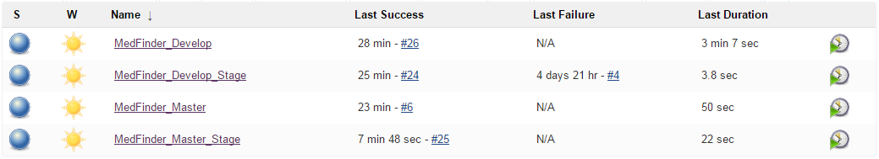

Figure : Jenkins Jobs for MedFinder

The *MedFinder_Develop* job compiles the application code from the develop branch into a deployable WAR file along with running unit tests and static code analysis tools. A PDF of the build page can be seen at <https://github.com/HarmoniaHoldings/medfinder/tree/master/documentation/Continuous_Integration/MedFinder_Develop%20%5bJenkins%5d.pdf>. The page shows the charts produced from the static code analysis tools like FindBugs and PMD, warnings from Java and JavaDoc, unit test results, and unit test code coverage. The details of the code coverage can be seen at [https://github.com/HarmoniaHoldings/medfinder/tree/master/documentation/Unit_Tests/MedFinder Unit Test Coverage.pdf](https://github.com/HarmoniaHoldings/medfinder/tree/master/documentation/Unit_Tests/MedFinder%20Unit%20Test%20Coverage.pdf).

The *MedFinder_Develop_Stage* build runs automatically upon a successful build of MedFinder_Develop. It deploys the WAR file to the stage server. A PDF of the build page can be seen at [https://github.com/HarmoniaHoldings/medfinder/tree/master/documentation/Continuous_Integration/MedFinder_Develop_Stage [Jenkins].pdf](https://github.com/HarmoniaHoldings/medfinder/tree/master/documentation/Continuous_Integration/MedFinder_Develop_Stage%20%5bJenkins%5d.pdf).

The *MedFinder_Master* job performs the same activities as the MedFinder_Develop build but for the master branch. A PDF of the build page can be seen at [https://github.com/HarmoniaHoldings/medfinder/tree/master/documentation/Continuous_Integration/MedFinder_Master [Jenkins].pdf](https://github.com/HarmoniaHoldings/medfinder/tree/master/documentation/Continuous_Integration/MedFinder_Master%20%5bJenkins%5d.pdf).

The *MedFinder_Master_Stage* build runs automatically upon a successful build of MedFinder_Master. It deploys the WAR file to the production server, which is the Amazon Web Services (AWS) instance. A PDF of the build page can be seen at [https://github.com/HarmoniaHoldings/medfinder/tree/master/documentation/Continuous_Integration/MedFinder_Master_Stage [Jenkins].pdf](https://github.com/HarmoniaHoldings/medfinder/tree/master/documentation/Continuous_Integration/MedFinder_Master_Stage%20%5bJenkins%5d.pdf).